Testimonials from Clients and Peers in Reference to Mark Foy

Mark Foy
Berkeley, California, USA [San Francisco Bay Area]
E-mail = MarkFoyJob@gmail.com (optionally put [MARK] at beginning of subject)
( Latest testimonials (and latest resume) available at: https://www.vitalita.com/staff/mfoy.html )
( LinkedIn = https://www.linkedin.com/in/markfoy )

*****

(A) RECOMMENDATIONS RECEIVED ON LINKEDIN
(can also view recommendations directly on LinkedIn at https://www.linkedin.com/in/markfoy)

From my Program Manager that I worked under for 3 years at Twitter:
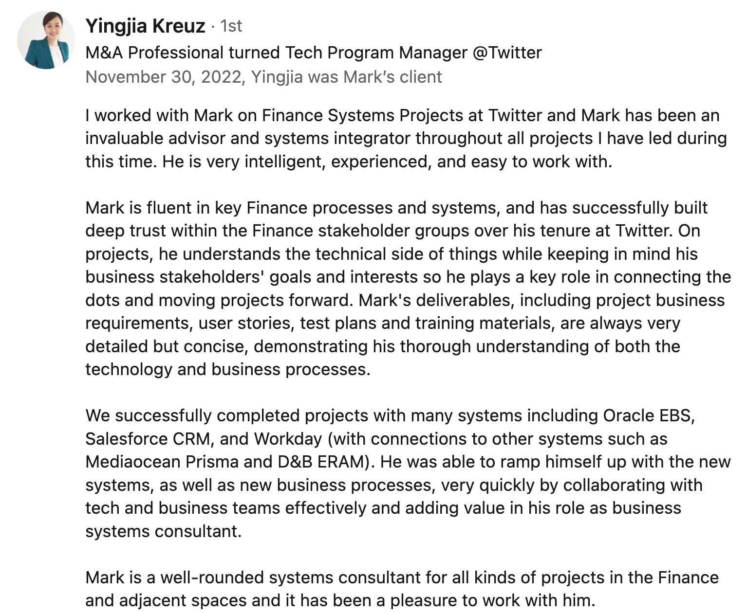

“I worked with Mark on Finance Systems Projects at Twitter and Mark has been an invaluable advisor and systems integrator throughout all projects I have led during this time. He is very intelligent, experienced, and easy to work with.

Mark is fluent in key Finance processes and systems, and has successfully built deep trust within the Finance stakeholder groups over his tenure at Twitter. On projects, he understands the technical side of things while keeping in mind his business stakeholders' goals and interests so he plays a key role in connecting the dots and moving projects forward. Mark's deliverables, including project business requirements, user stories, test plans and training materials, are always very detailed but concise, demonstrating his thorough understanding of both the technology and business processes.

We successfully completed projects with many systems including Oracle EBS, Salesforce CRM, and Workday (with connections to other systems such as Mediaocean Prisma and D&B ERAM). He was able to ramp himself up with the new systems, as well as new business processes, very quickly by collaborating with tech and business teams effectively and adding value in his role as business systems consultant.

Mark is a well-rounded systems consultant for all kinds of projects in the Finance and adjacent spaces and it has been a pleasure to work with him.”

--

From a Senior Finance Systems Manager I collaborated with at Twitter:
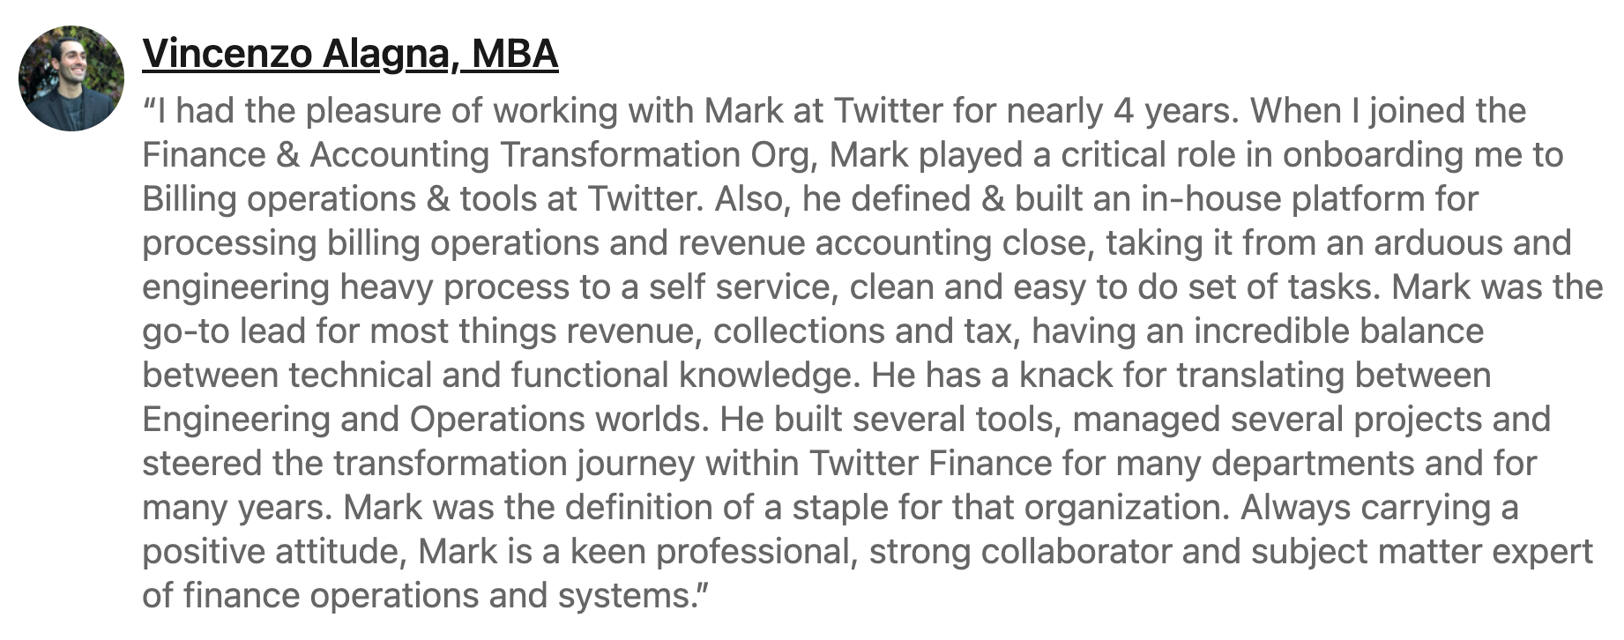

“I had the pleasure of working with Mark at Twitter for nearly 4 years. When I joined the Finance & Accounting Transformation Org, Mark played a critical role in onboarding me to Billing operations & tools at Twitter. Also, he defined & built an in-house platform for processing billing operations and revenue accounting close, taking it from an arduous and engineering heavy process to a self service, clean and easy to do set of tasks. Mark was the go-to lead for most things revenue, collections and tax, having an incredible balance between technical and functional knowledge. He has a knack for translating between Engineering and Operations worlds. He built several tools, managed several projects and steered the transformation journey within Twitter Finance for many departments and for many years. Mark was the definition of a staple for that organization. Always carrying a positive attitude, Mark is a keen professional, strong collaborator and subject matter expert of finance operations and systems.”

*****

(B) SHOUTOUTS FROM TWITTER COLLEGUES:
Shoutouts for Mark Foy from Twitter colleagues:

From a Credit and Collections stakeholder:
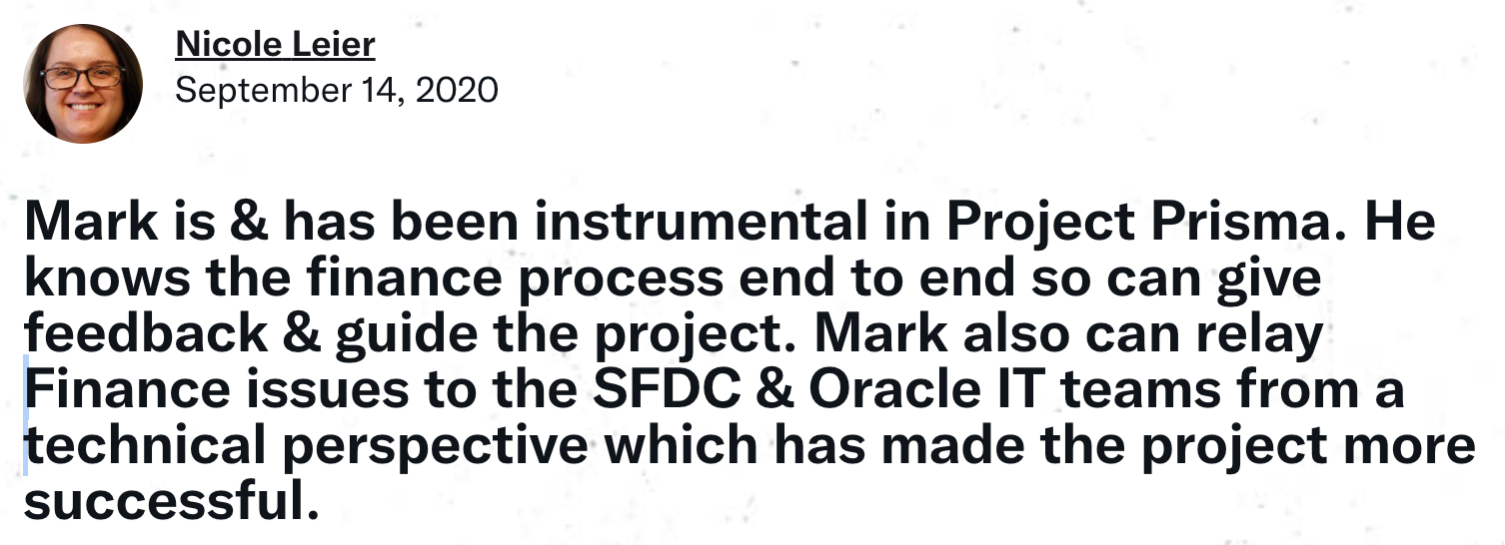

“Mark is & has been instrumental in Project Prisma. He knows the finance process end to end so can give feedback & guide the project. Mark also can relay Finance issues to the SFDC & Oracle IT teams from a technical perspective which has made the project more successful.”

--

From an OTC (Revenue Operations) stakeholder:
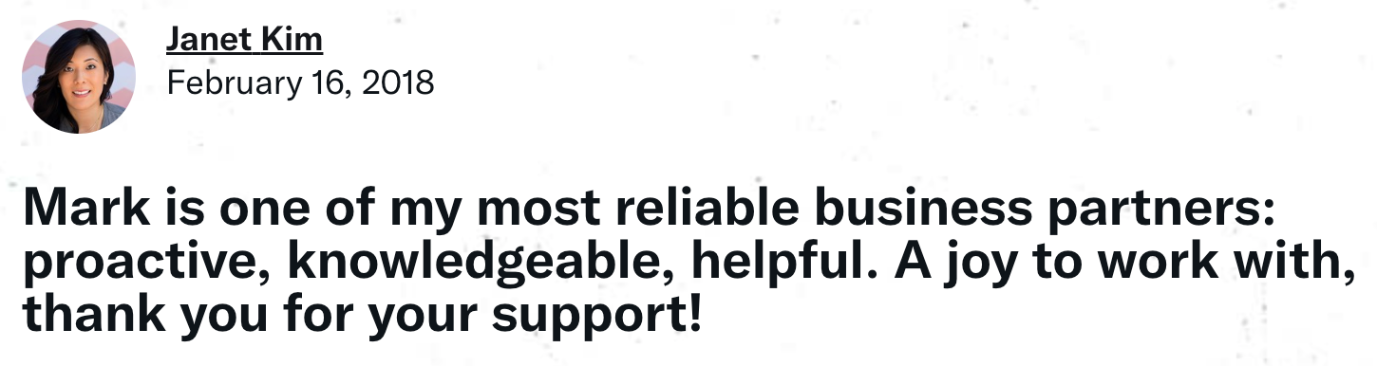

“Mark is one of my most reliable business partners: proactive, knowledgeable, helpful. A joy to work with, thank you for your support!”

--

From a Credit and Collections stakeholder:
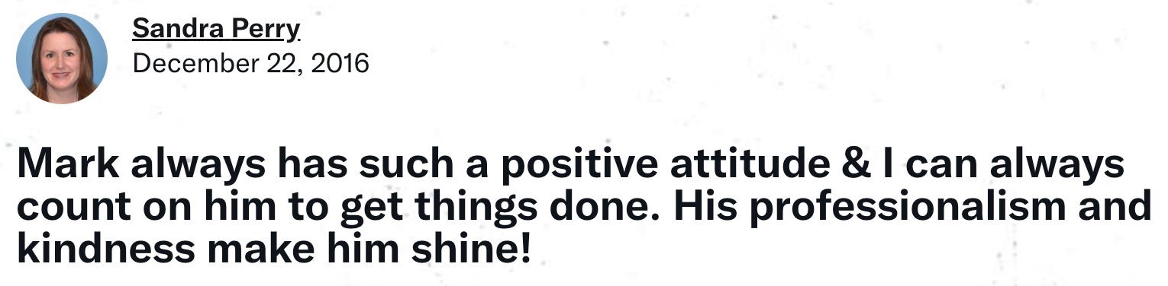

“Mark always has such a positive attitude & I can always count on him to get things done. His professionalism and kindness make him shine!”

--

From an Order to Cash (Billing) stakeholder:
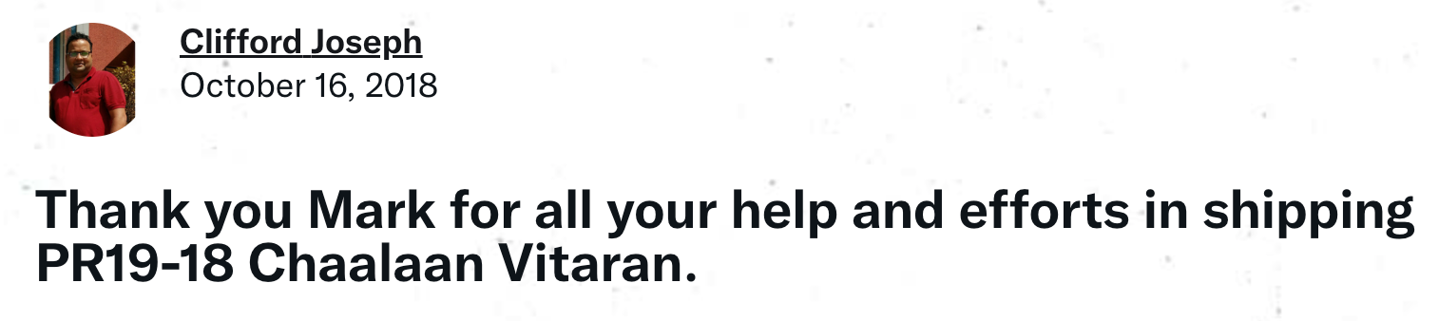

“Thank you Mark for all your help and efforts in shipping PR19-18 Chaalaan Vitaran.”

--

From an OTC (Revenue Operations) stakeholder:
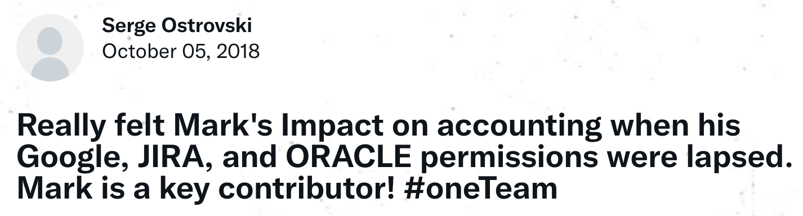

“Really felt Mark's Impact on accounting when his Google, JIRA, and ORACLE permissions were lapsed. Mark is a key contributor! #oneTeam”

--

From a People Systems stakeholder:
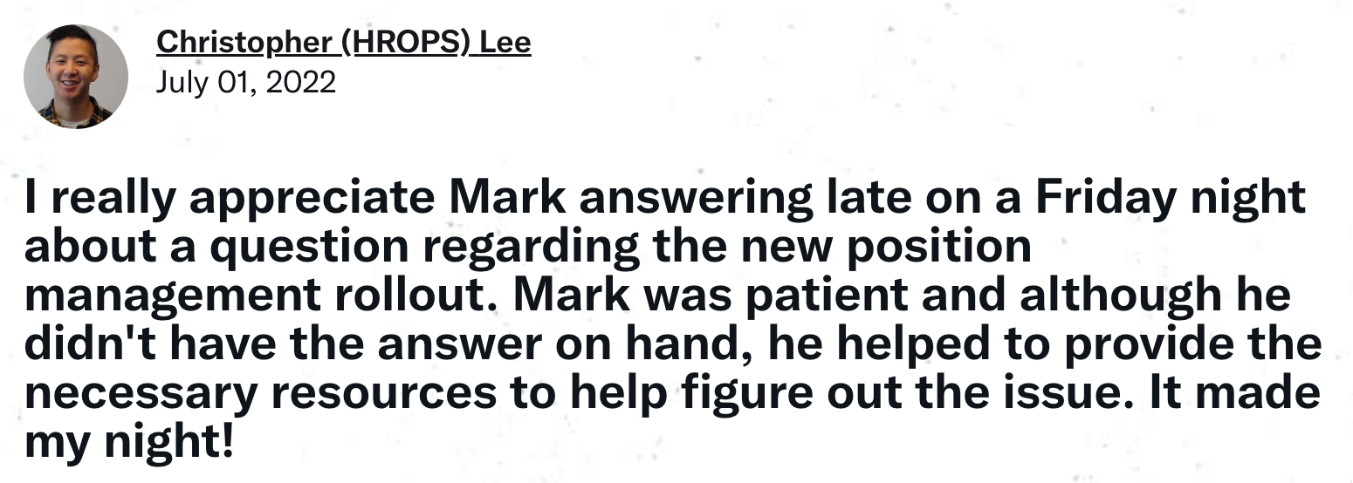

“I really appreciate Mark answering late on a Friday night about a question regarding the new position management rollout. Mark was patient and although he didn't have the answer on hand, he helped to provide the necessary resources to help figure out the issue. It made my night!”

--

From a OTC (Billing) stakeholder:

“Thank you for your help and support @3am to get Global billing completed. #Rockstar”

--

From a Credit and Collections stakeholder:
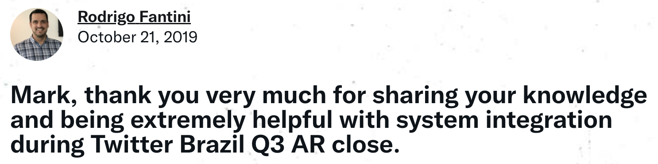

“Mark, thank you very much for sharing your knowledge and being extremely helpful with system integration during Twitter Brazil Q3 AR close.”

--

From an OTC (Revenue Operations) stakeholder:
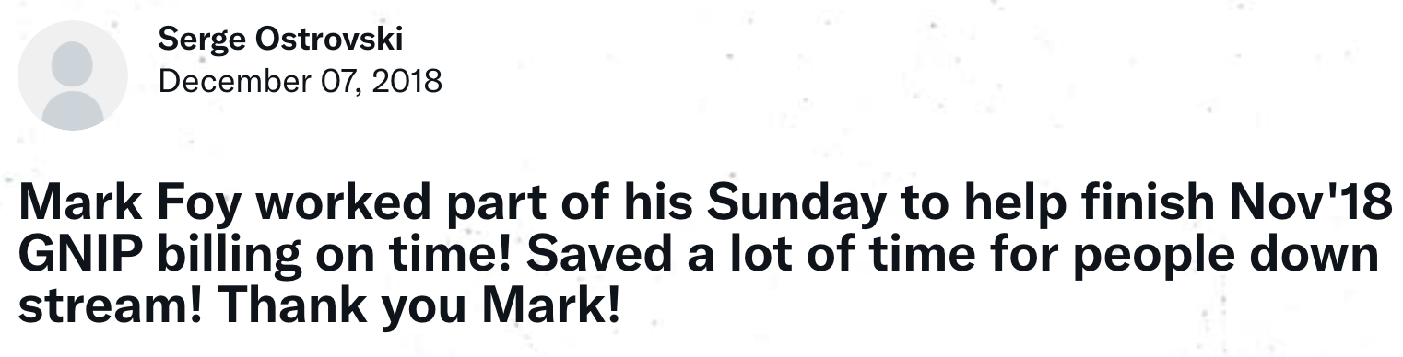

“Mark Foy worked part of his Sunday to help finish Nov'18 GNIP billing on time! Saved a lot of time for people down stream! Thank you Mark!”

--

From an OTC (Billing) stakeholder:
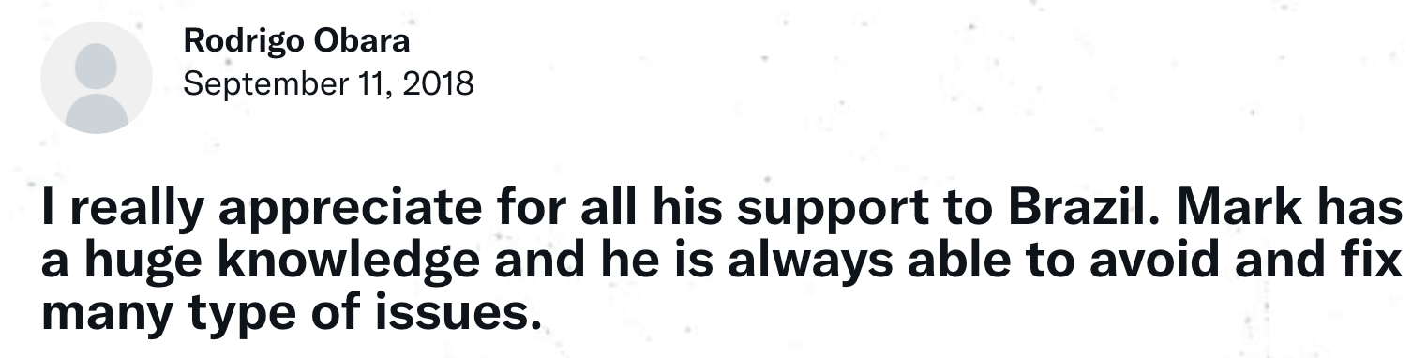

“I really appreciate for all his support to Brazil. Mark has a huge knowledge and he is always able to avoid and fix many type of issues.”

--

From an OTC (Revenue Operations) stakeholder:
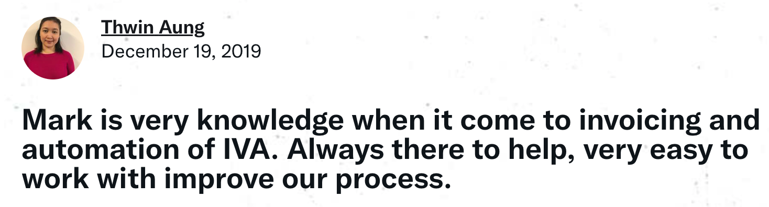

“Mark is very knowledge when it come to invoicing and automation of IVA. Always there to help, very easy to work with improve our process.”

*****

(C) MORE RECOMMENDATIONS RECEIVED ON LINKEDIN
(can also view recommendations directly on LinkedIn at https://www.linkedin.com/in/markfoy)

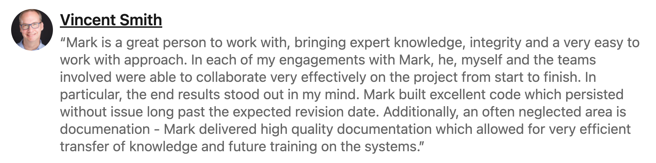

“Mark is a great person to work with, bringing expert knowledge, integrity and a very easy to work with approach. In each of my engagements with Mark, he, myself and the teams involved were able to collaborate very effectively on the project from start to finish. In particular, the end results stood out in my mind. Mark built excellent code which persisted without issue long past the expected revision date. Additionally, and often neglected area is documentation - Mark delivered high quality documentation which allowed for very efficient transfer of knowledge and future training on the systems.”

--

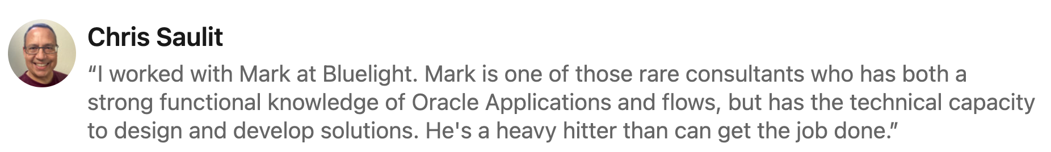

“I worked with Mark at Bluelight. Mark is one of those rare consultants who has both a strong functional knowledge of Oracle Applications and flows, but has the technical capacity to design and develop solutions. He’s a heavy hitter that can get the job done.”

*****

(D) LETTERS RECEIVED:

*****

MAXIMUS / CALRECYCLE

Dear Mark,

I am writing this letter to thank you for your outstanding work on the DORIIS project. Your Oracle functional expertise and attention to detail were tremendously valuable on the project.

You joined the project at a very busy and critical time. You were able to quickly understand the objectives and priorities and make positive, quality contributions to the design, configuration, and testing processes. The quality of your work was recognized and appreciated by other functional team members, the client, and technical staff alike.

Again, I would like to express my sincere thanks for your contributions to our successful implementation of the DORIIS project. I look forward to the opportunity to work together again.

Sincerely,

Jeff J. Dew
Project Director
Maximus ERP Solutions

*****

XILINX

To Whom It May Concern:

Mark is a great person to work with, bringing expert knowledge, integrity and a very easy to work with approach. In each of my engagements with Mark, he, myself and the teams involved were able to collaborate very effectively on the project from start to finish. In particular, the end results stood out in my mind. Mark built excellent code which persisted without issue long past the expected revision date. Additionally, an often neglected area is documentation - Mark delivered high quality documentation which allowed for very efficient transfer of knowledge and future training on the systems.

Vincent Smith
PMP
Xilinx

*****

GE ACCESS

To Whom It May Concern:

In my role as Information Technology Project Manager at GE Access, I was tasked with converting legacy Service Business into the Oracle Financials System. The project budget was approximately $2 million and consisted of over 15 developers with a duration of twelve months.

Mark quickly emerged as a leader among is peer group. He was highly successful in his role as Development Team Leader. Excellent communication and leadership skills created a highly functional team who accomplished a tremendous amount of quality work in very short timelines.

As this was my first major project, Mark acted as a mentor to me. His experience and expertise guided me to the successful completion of a very difficult task. I depended on him for coaching with regard to communication skills as well as strategy and vision creation.

The project had a large impact to the business. Therefore, there was pressure to implement quickly. The pre-chosen software did not accommodate functionality requirements. Mark presented several options with both pro and cons. This enabled executive management to make informed decisions with regard to customizations. Mark always explores every option without judgment.

Mark has the ability to transition from a technical role to a management role where appropriate. The skill to "bridge the gap" between the technical and the functional make him an excellent facilitator between IT and the business. Rarely does a person possess this exceptional talent.

Overall, Mark was a tremendous contributor to the success of the Service implementation. He successfully completes work either through individual effort or through the leadership of others. He works with the highest level of honesty and integrity. The quality of his work consistently exceeds expectations. I highly recommend him and any resource that he endorses.

Denise Peters
IT Project Manager
GE Access

*****

GE IT DISTRIBUTION GROUP

To Whom It May Concern:

I would like to take the opportunity to describe the work that Vitalita Consulting, and, specifically, Mark Foy, performed for me as Manager of Applications Development at Access Graphics.

Mark has a firm grasp of technical details and takes the time to document them. Mark is also highly skilled at recognizing issues that require escalation to management for decision-making. Typically, Mark tackles this by presenting a number of well thought-out options with pros and cons to aid the decision maker in making choices and in understanding and communicating the implications of that choice.

Mark is an excellent organizer and deals effectively both with technical people and with those to whom he reports. Superior under stress, Mark actually appears to become more calm and more patient as stress escalates or conflicts emerge, making him an extremely valuable lead team member who can inspire excellent performance, ensure accountability, and build bridges even under duress.

In short, I would consider any company very lucky to have Mark join the team, as he is virtually a shoo-in for creating the atmosphere and structure necessary to bring in a successful project. Witness the success of the huge, multi-million dollar upgrade of the highly customized Oracle Financials applications for Y2K, which was delivered on schedule, under budget, and with high quality. Mark’s qualities and work ethic underpinned that success. I would highly recommend Mark in any project that involves complexity, tough time constraints, or high quality requirements.

Sincerely,

Cheryl Dopp
Manager of Applications Development

*****

SHOPNBC (NBC/GE/VALUEVISION MEDIA)

To whom it may concern,

Mark Foy was brought into the ShopNBC account on behalf of Motion International to assist in the stabilization of an 11i complete suite implementation and conversion from a non-Oracle system during 2002 and 2003. His unique combination of functional, business and technical skills allowed him to contribute in ways that others could not. He allowed us to delegate complete identification, root cause analysis, and corrective actions (with clean-up scripts) to be put in place without worrying about the ball being dropped. Mark consistently provided solid documentation of his findings and solid counsel and advice to the client about the options available to solve problems. In many cases his expertise of Oracle’s 11i suite provided for quick diagnosis and decisions to be tee’d up for management to make.

I will likely call on Mark again when we get into a pinch with 11i. He is a great team player and integrated well within our team here in Minnesota.

Damon Metts
Director of Development
Information Technology
ShopNBC (ValueVision Media)

*****

ACCESS GRAPHICS

To whom it may concern:

In my role as Oracle Applications Director at Access Graphics, I have had the responsibility of filling technical and management positions in Information Technology. Earlier this year, I moved out of this role to a new position in the company. During my tenure as Applications Director, I employed many consultants from many different consulting agencies to fulfill the development and management needs for our Oracle Applications system. Many consulting agencies have provided very competent resources, but the consultants provided by Vitalita have excelled within our organization. They have become key resources on some of our most important projects.

Specifically, Mark Foy has been an ongoing consulting resource within our organization since October 1997. We originally brought Mark in based on his strong technical skills. He started working on development within the reporting group and the EDI group. He easily adapted to our business environment, and became an important contributor to the growth in these areas. We were impressed with his knowledge, methods, and thoroughness. Based on this, we included him in our Oracle Applications 10.7 upgrade project. In this project, he started out evaluating our extensive set of custom and standard Applications code. Excelling in this role, we moved him into the position of Development Team Technical Lead where he managed and coordinated the efforts of seven developers for 5 months. His ability to cooperate and communicate with everyone on our staff, helped us achieve a very successful upgrade.

Additionally, we brought on another member of Vitalita, Therron Hofsetz, in September of 1998 to be Project Manager for the Oracle Applications 10.7 upgrade. Therron played a key role in coordinating the efforts of all the groups involved in the project (infrastructure, development, configuration management, users, management, etc.). Therron personality makes him very easy to work with, and his extensive functional background ensured that all aspects of the project were being addressed. He kept the group working as a team towards a common goal of bring the project in on time and within budget.

In general, the consultants from Vitalita have very strong technical and business backgrounds that have enabled them to make significant contributions to our organization. They have demonstrated an ability to quickly understand complex issues and provide innovative and sound solutions.

Overall, our organization has been extremely pleased with the resources provided by Vitalita, and I would highly recommend them to other organizations.

JoAnn Miller
Oracle Applications Director, Information Technology
Access Graphics

*****

BLUELIGHT.COM (KMART)

To Whom It May Concern:

As Technical Applications Manager at Bluelight.com, I have managed many different Oracle Applications technical and function people. During the first 4 months of 2001, I hired Mark Foy as a consultant in my group, and this letter is to comment on my experience working with Mark.

Mark was immediately thrown into a rapidly changing group, where learning our customized system and producing enhancements was critical. Bluelight was in the process of rolling off the Oracle Professional Services consultants we had hired for the last year to customize and implement our Oracle Applications system. Therefore, Mark had to quickly assimilate knowledge of the system technical design and customizations from the departing consultants. Mark was tasked with learning all customizations and functionalities of the order entry system, the warehouse interface, and some parts of the inventory interface. We were very happy that Mark was able to quickly come up to speed in these areas, and then immediately begin to perform business-critical additions and changes.

In particular, I was very impressed with the way Mark carried out his work, from analysis to implementation and post-production support. His analysis was always very complete, and easily understood by users and management so different system extension options could be evaluated with all relevant information. He has the rare ability to be able to effectively communicate will all different types of people (technical peers, supervisors, end users, etc.), and this was definitely an asset within our organization. Other developers and QA personnel were able to learn a lot from Mark because he can clearly communicate complex ideas in a methodical style. Mark was able to quickly scope requested enhancements, and give solid estimates of how long it would take to produce high quality, well-tested solutions. His organizational skills were valued because he could effectively schedule and manage his work, without me having to give guidance every step of the way.

Mark is a very skilled software engineer with good documentation skills. We did many production pushes of code Mark had developed and tested, and I can only recall one occasion where we had a problem with the code push. Overall, his code seemed virtually bug-free, and other developers appreciated how he documents his code so that it can be easily understood in the future.

In summary, I would definitely hire Mark again, and would recommend him to other companies without hesitation. He brings a long and varied background in information technology that can be hard to find today, and Bluelight definitely benefited by employing his consulting services.

Sincerely,

Roger Shirakawa
Technical Applications Manager, Information Technology
Bluelight.com

*****

U S WEST COMMUNICATIONS

Memo to: Current and Prospective Employers of Information Systems Personnel

In my 25-year career with U S WEST Communications, I have most recently held the positions of Engineering Systems Mechanization Project Manager and Technical Project Manager. My primary responsibilities included project oversight, client requirements gathering and direct interface with the development staffs. My charge was to understand client needs, ensure the developers understood those needs and developed programs that would satisfy their requirements. I have worked with scores of developers, many of them technically competent, many who could speak to management and end users on whatever level necessary and even a few who were creative and were able to present fresh ideas. But, in my experience, there has been only one individual whom I would recommend unconditionally to others, Mark Foy.

Mark worked as a technical consultant on a project of which I was the Technical Project Manager from February 1996 until October 1997. From the very start he proved himself to be highly competent technically. In addition, he was required to perform under very difficult, stressful circumstances, often with nearly impossible deadlines and conflicting directions. Client requirements changed weekly, sometimes as often as hourly. He was expected to produce a high quality product on a schedule that would have caused most developers to just quit. Not Mark. Not only did he remain completely unruffled under pressure, he produced a product of extraordinarily high quality and made many creative, useful suggestions to improve the results. He was called up to work with a very diverse group of people, some quite difficult. Mark worked well with everyone and kept focused in a highly chaotic environment. His technical excellence makes it a pleasure to work with him but where I believe his star shines most brightly is his ability to speak to anyone, at any level, without being condescending or unnecessarily technical. That is a quality very few developers possess.

I strongly recommend Mark Foy for any position where you need technical expertise, creativity, and the ability to work under extreme pressure. You will receive the wonderful bonus of being able to just talk to him and know that he can and will help you achieve your goals.

I realize this may sound too good to be true. I assure you it is accurate and will be happy to discuss my experiences with him if you require any additional information. What I do know is if I had serious Y2K issues, required system development or maintenance, needed to get out of trouble in an existing system or wanted to develop a web site to expand my business to the internet, I would call Mark Foy.

A. B. (Bea) Wampole
RTT Technical Project Manager
Information Technology Systems
U S WEST Communications

*****

LUCENT TECHNOLOGIES

From: Nicole M. Lewis
Member of Technical Staff
Lucent Technologies

To Whom It May Concern:

I have worked with Mark Foy approximately 2 years at U S WEST on several projects. I am a Systems Engineer responsible for writing detailed requirements and have partnered with Mr. Foy on several occasions.

Mark has exemplified the following:
+ Has complete understanding of "big picture" scenarios
+ Adapted to the U S WEST business environment easily
+ Completes ‘quality’ work quickly
+ Is extremely knowledgeable
+ Incorporates new technology into client requests
+ Flexibility in accommodating clients change requests

In closing, Mark has been one of the few consultants that has been flexible, knowledgeable, and considerate of user/client needs in my 15 years work experience.

Nicole M. Lewis

*****

GE IT DISTRIBUTION GROUP

To Whom It May Concern:

As EDI Coordinator at Access Graphics/GE IT Distribution, I have known Vitalita consultants since December of 1997. In that time, I have been very impressed with the service these consultants have provided to our company. The consistency of the service they provide is very good and the quality of their work is very high. I have worked with two consultants from Vitalita during the last one and a half years: Mark Foy and Therron Hofsetz.

Mark Foy worked as a software engineer for the EDI group directly for about 3 months before I joined the EDI group, and then for 5 months while I lead the EDI group. As his role became more focused toward his position as Development Team Lead for Access Graphics’ 10.7 Oracle Applications upgrade, his involvement in the EDI group was reduced. During the 8 months he was developing on EDI programs and system, he worked very hard to help us achieve some of our aggressive business objectives in electronic commerce. Mark was able to implement many new EDI transactions with our business partners under significant time pressures. I believe we were very lucky to have his software engineering background within our group so we could produce high-quality, effective, expandable programs that were bug free and could be implemented in a production environment very quickly. Mark also assisted greatly in upgrading our EDI programs and systems for Oracle Applications 10.7 and Y2K compliance, ensuring a successful upgrade of our Oracle Financials, Manufacturing, and Distribution modules.

Overall, I want to complement the Vitalita consultants for their consistency, quality of work, and contribution to our organization, and say that I would recommend their consulting services to other organizations.

Wendy Melcher
EDI Coordinator
Access Graphics/GE IT Distribution

*****

GE ACCESS

Subject: Reference for Mark Foy

This document is meant as a reference for Mark Foy.

I was involved in 2 different projects with Mark. First, a large long term (Oracle Applications) project (huge development team) that was very difficult to implement and second a short term make it work fast and now type project that had huge direct impact on my organization. Both were completed satisfactorily and on-time. Specifically, the second one was wildly successful and instrumental to my organization.

I have found Mark to be:

1. Reliable
2. Knowledgeable
3. Concerned about quality
4. Willing to go the extra mile
5. A good communicator
6. Eager to help.
7. Someone with strong development skills
8. Someone with good project management skills
9. Someone I would go to to understand the real issues I needed to be aware of concerning functional impact to my organization or understanding how to go about integrating a solution to existing environments.

I hope my company continues to use him as we go forward into the future, as I perceive he is the kind of quality individual it takes on a team to be successful.

Thank You Mark for your excellent support, direction and efforts in our time working together.

GE Access

Greg Webb
Manager, Strategic Client Support

****

U S WEST COMMUNICATIONS

To Whom It May Concern,

This purpose of this letter is to express my complete satisfaction with the consulting services provided by Mark Foy.

Mark and I worked together on a large scale HP UNIX client/server application using ORACLE RDBMS. Mark functioned in the dual roles of developer and technical lead for our main application, as well as several sub-systems. His expertise in the areas of UNIX, ORACLE, ORACLE Web Server, C language, and SQL Stored Procedures was invaluable to our project’s success.

Regarding work ethic, Mark completes his work quickly and with the highest quality. On more than one occasion, Mark was given total responsibility for developing critical components to our systems and each time he delivered total quality software. From initial analysis through final delivery, Mark worked with various technical staff on user requirements analysis, software data modeling, task definition and estimation, and overall project management.

With regard to client and peer interaction, Mark always received the highest praise. During his short time at US West, he built a reputation as a technical expert, sought out by both IT management and IT professionals. Overall, Mark is very easy to work with. He adapts to new systems and technology while performing complete problem definition research. Mark is able to communicate his technical ideas with both technical and non-technical peers alike. He works well with difficult people and performs well under stress. In closing, I would welcome the opportunity to work with Mark again.

Respectfully,

John P. Escamilla
Software Engineer/Member of Technical Staff
US West Communications

*****

U S WEST COMMUNICATIONS

RE: Recommendation for Mark Foy

To Whom It May Concern:

I had the opportunity and privilege to work with Mark Foy from approximately June, 1996 through August, 1997. During this time I interfaced with Mr. Foy in the capacity of System Administrator, Project Manager, and later System Engineer, while Mark’s role remained constant as a Consultant and Programmer. The following is a summary of my assessment of his job performance:

Mark’s demeanor is thoughtful, attentive, calm and friendly, even under the most stressful of circumstances and working with the most difficult of people. He takes time to gather facts, insuring he is reacting to all facts and not partial data, and thus produces consistent, high-quality results. I have worked with Mark on massive projects (entailing data conversion from an antiquated mainframe application to a client-server architecture) to routine software releases. Mark was always very timely with completion of his work, if not ahead of schedule, and was deemed as a source of knowledge and competency by fellow developers as well as clients. I highly recommend Mark Foy’s talent and expertise, as an individual and as a professional.

Respectfully,

Barbara J. Johnston
Manager – U S WEST Long Distance

*****

U S WEST COMMUNICATIONS

Subject: REFERENCE

I worked with Mark Foy at US West for approximately 2 years. At that time, we both worked in a highly fast paced development environment.

As a DBA I supported an extremely complex system consisting of 2 Oracle databases. Mark supported development of multiple programs to support the following types of user requirements for this system:

Data conversions from a large VM system to the Oracle primary Application and Datawarehouse databases.

End of Month and report processes from the Datawarehouse database.

Interface programs from both databases to Mainframe/DB2 databases using Oracle Gateway to DB2 and Socket technology.

All aspects of Mark's job consisted of learning new technology. Mark always made the extra effort to completely understand how to use the new technologies. He was very thorough and responsive to the development requests he received. Mark also supported the production environment during data conversions.

Mark worked well with all personnel he had to interface with. His attention to detail and drive to completely understand the issues as well as the complexities involved was instrumental in the success of our efforts.

All of Mark's work was of high quality and he performed above our expectations in everything he was assigned.

--
Tina Gregory
Oracle DBA
Mineral Pre-Production Group

*****

U S WEST COMMUNICATIONS

In 1997 Mark Foy worked as a consultant on a project at U S WEST for which I was the technical lead. I am happy to take this opportunity to tell how pleased I am with his contributions.

The application was required to produce reports, both real-time and overnight, from a large Oracle database. The architecture used a Web front-end, an early version of the Oracle Web Server for listener and PL/SQL cartridge, and PL/SQL packages for the application code. The project was characterized by high visibility, rapidly changing requirements, a political client group and a need to produce a lot quickly. We met a long series of deadlines successfully, mostly because of Mark’s efforts.

Mark made several significant contributions.
+ He adopted a new technology to meet our requirements. This way of producing a reporting interface had been demonstrated in a pilot project. Mark made it work in a much larger setting, facing down many technical problems with the Oracle infrastructure.
+ He worked well with a very demanding client community. The requirements evolved rapidly, the end result had to meet stringent legal restrictions, and the work had executive-level attention. Mark was able to listen well to client requests, meet challenging requests when possible, and keep them happy even when delivering bad technical news that some things could not be done the way they wanted. He showed a lot of initiative in this area.
+ He readily grasped the regulatory climate that determined many of our requirements. As a result, Mark was able to help the client fine-tune some fuzzy requirements into precise specifications.
+ He communicated well with a changing cast of developers and DBAs. New people had to be taught this unfamiliar application architecture, and be coached to use a uniform style. Mark was patient and helpful with all the technical staff.
+ He produced work of high quality with amazing speed. He was the most productive developer on the project.

In summary, Mark has equally strong technical and interpersonal abilities. In a technical role he has a strong ability to quickly grasp complex technology and wield it effectively to meet requirements. In an interpersonal role he works very well with clients and technical people. I would gladly use his consulting services again, and recommend him highly.

Dan Moore
U S WEST Information Technologies

*****

U S WEST COMMUNICATIONS

Letter of Recommendation

Mark Foy and I were both consultants on the same assignment at US West. As the test lead for the development project, I worked closely with the development staff.

Mark performed quality work in a sometimes stressful and deadline-driven environment. He was an excellent team player and interacted very well with all the staff members. Mark had excellent knowledge of the technology and was willing to share his expertise with other members of the team.

Mark was very accommodating to the clients in meeting their requests for changes to the application. Mark often took the initiative to ensure the client requests were fulfilled in a timely manner.

Mark was very receptive and prompt in dealing with the test team to resolve all issues during the system test cycle.

I would welcome the opportunity to work with Mark Foy again.

Pam Norwood
Technical Consultant

*****

ACCESS GRAPHICS

To Whom It May Concern:

I have worked as a peer with Mark Foy for about a year and have found him to be technically proficient and personally easy to work with. I value his technical opinion and therefore often ask his advice when I have a technical problem. He's always willing to listen to my question and offer ideas. He has followed up by mailing me code examples that are pertinent to my question. Mark is a pleasant person to work with. I'd be happy to answer questions at my home number, 666-8684.

Cordially,

Jennie Elliott

